Digital Safety & Near-Miss Management System

Software Requirements Specification (SRS) and High-Level Architecture Document

Part A: Software Requirements Specification (SRS)

1. Introduction

1.1 Purpose
This Software Requirements Specification (SRS) document formally defines the functional and non-functional requirements of the Digital Safety & Near-Miss Management System. The system provides a structured and reliable digital platform for reporting, tracking, analyzing, and managing workplace safety incidents and near-miss events. This document serves as a single, authoritative reference for developers, project stakeholders, and academic evaluators.

1.2 Scope
The Digital Safety & Near-Miss Management System is designed to enhance workplace safety by replacing manual, paper-based reporting processes with a centralized digital solution. Employees can easily report incidents and near-misses, while safety officers and management can systematically review reports, identify risk patterns, take corrective and preventive actions, and ensure compliance with organizational safety standards.

1.3 Intended Audience
- Project guide and academic evaluators
- Development team
- Safety officers and management personnel
- End users (employees)

1.4 Definitions and Acronyms
- Near-Miss: An unplanned event that did not result in injury or damage but had the potential to do so
- Incident: An event that results in injury, damage, or loss
- SRS: Software Requirements Specification

2. Overall Description

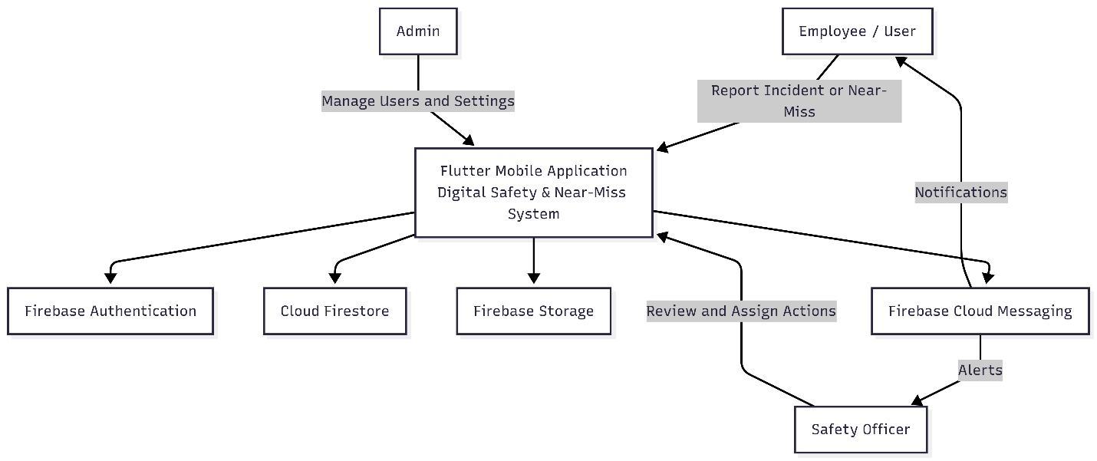
Figure 1: System Context Diagram of the Digital Safety & Near-Miss Management System

2.1 Product Perspective
The system is a standalone digital application based on a client-server architecture. It utilizes cloud-based, serverless backend services and integrates directly with Firebase services for authentication, data storage, and notifications.

2.2 Product Functions
- Secure user registration and authentication
- Digital reporting of safety incidents and near-miss events
- Categorization and prioritization of reported events
- Review, validation, and approval of reports by safety officers
- Assignment and tracking of corrective and preventive actions
- Generation of safety analytics and summary reports
- Real-time notifications and alerts

2.3 User Classes and Characteristics
User Role | Description | Key Responsibilities
Employee / User | General system user | Report incidents and near-misses, track report status
Safety Officer | Safety management authority | Review reports, investigate events, and assign corrective actions
Admin | System administrator | Manage users, roles, categories, and system settings

2.4 Operating Environment
- Android-based mobile application
- Optional web-based administrative dashboard
- Cloud-hosted, serverless backend infrastructure

2.5 Design Constraints
- Compliance with safety, privacy, and data protection standards
- Limited development timeline and academic resources
- Simple and intuitive user interface for non-technical users

2.6 Assumptions and Dependencies
- Users have access to smartphones
- Stable internet connectivity is available
- Organizational support exists for digital safety reporting

3. Use Case Model

3.1 Use Case Overview
The use case model illustrates how different users interact with the Digital Safety & Near-Miss Management System to achieve specific goals. It identifies system actors and defines their interactions with core system functionalities.

3.2 Actors
- Employee / User: Reports incidents and near-miss events and monitors report status
- Safety Officer: Reviews reports and assigns corrective and preventive actions
- Admin: Manages users, roles, and system configuration

3.3 Use Case List
Use Case ID | Use Case Name | Primary Actor
UC-01 | User Login | All Users
UC-02 | Report Incident | Employee
UC-03 | Report Near-Miss | Employee
UC-04 | Review Safety Report | Safety Officer
UC-05 | Assign Corrective Action | Safety Officer
UC-06 | View Notifications | All Users
UC-07 | Manage Users | Admin

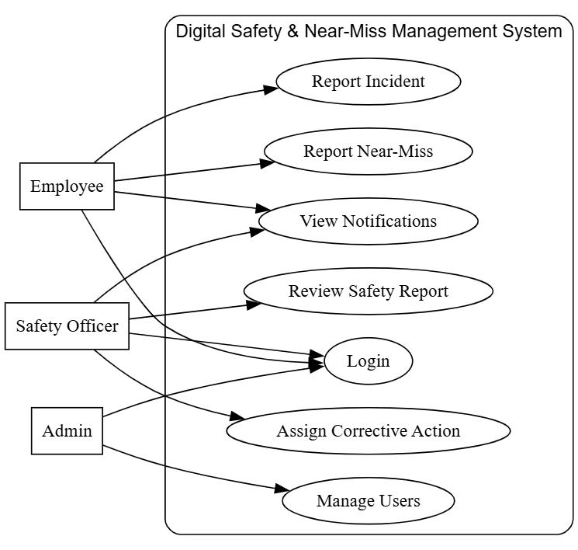
Figure 2: Use Case Diagram of the Digital Safety & Near-Miss Management System

3.4 Detailed Use Case Description (Example)
Use Case ID: UC-02
Use Case Name: Report Incident
Primary Actor: Employee
Preconditions: - The user is registered and logged into the system - Internet connectivity is available
Main Flow: 1. The employee selects the “Report Incident” option in the mobile application. 2. The system displays the incident reporting form. 3. The employee enters incident details such as date, location, description, and severity. 4. The employee submits the report. 5. The system validates the information and stores it securely. 6. The safety officer is notified of the new incident report.
Postconditions: - The incident report is successfully stored in the system. - The report status is set to “Submitted”.

4. Functional Requirements
FR ID | Functional Requirement | Description | User Role
FR-01 | User Authentication | Secure login and logout using valid credentials | All Users
FR-02 | Incident Reporting | Submit detailed safety incident reports | Employee
FR-03 | Near-Miss Reporting | Submit near-miss event reports | Employee
FR-04 | Report Review | Review and validate submitted reports | Safety Officer
FR-05 | Action Assignment | Assign corrective and preventive actions | Safety Officer
FR-06 | Notifications | Receive alerts and status updates | All Users
FR-07 | User Management | Manage users and roles | Admin

5. Non-Functional Requirements
NFR ID | Category | Description
NFR-01 | Performance | System should respond to user actions within acceptable time limits
NFR-02 | Security | User data must be encrypted and securely stored
NFR-03 | Usability | Application should be easy to use for non-technical users
NFR-04 | Reliability | System should ensure data consistency and availability
NFR-05 | Scalability | System should support growth in the number of users

6. External Interface Requirements

6.1 User Interface
- Mobile-friendly, responsive, and consistent design
- Simple and structured forms for incident and near-miss reporting

6.2 Software Interfaces
- Direct integration between the mobile application and backend services using Firebase SDKs

7. System Constraints
- Compliance with organizational safety policies and privacy regulations
- Operation on standard Android devices
- Limited cloud resource usage under free or academic plans

8. Data Entities Overview
Entity | Description
User | Stores user profile, role, and authentication details
Incident | Stores incident details such as date, location, severity, and description
Near-Miss | Stores near-miss event details and potential risk information
Corrective Action | Stores assigned actions, responsible person, and status
Notification | Stores notification messages and delivery status

9. Future Enhancements
- AI-based risk prediction and safety recommendations
- Advanced dashboards and visual analytics
- Integration with IoT-based safety monitoring devices

Part B: High-Level System Architecture

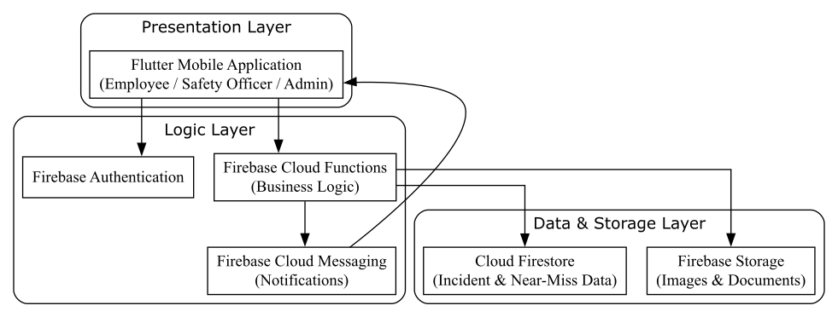
Figure 3: High-Level Layered Architecture of the Digital Safety & Near-Miss Management System

1. Architecture Overview
The Digital Safety & Near-Miss Management System follows a layered client-server architecture consisting of a mobile frontend, serverless backend services, and cloud-based data storage. The architecture is designed to be scalable, secure, and easy to maintain.

2. Major System Components

2.1 Mobile Application (Presentation Layer)
- Enables employees and safety officers to report incidents and near-miss events
- Allows users to track report status and assigned actions

2.2 Backend Services (Logic Layer)
- Implements core business logic and validation
- Manages authentication, authorization, and system workflows

2.3 Data and Storage Layer
- Stores user profiles, safety reports, corrective actions, and audit logs

2.4 Notification Service
- Sends real-time alerts and updates using push notifications

3. Component Interaction Flow

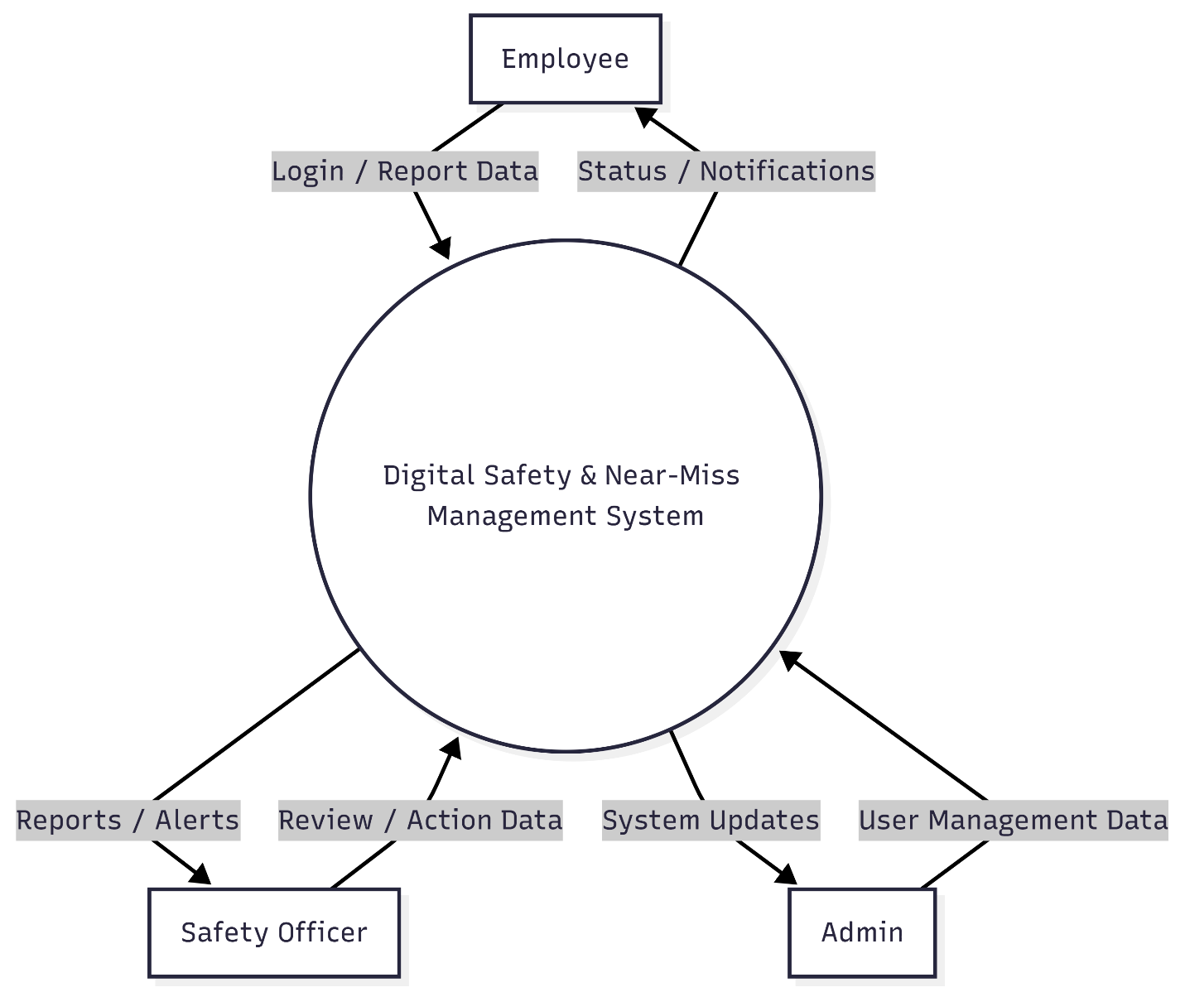
Figure 4: DFD Level 0 (Context Diagram) of the Digital Safety & Near-Miss Management System
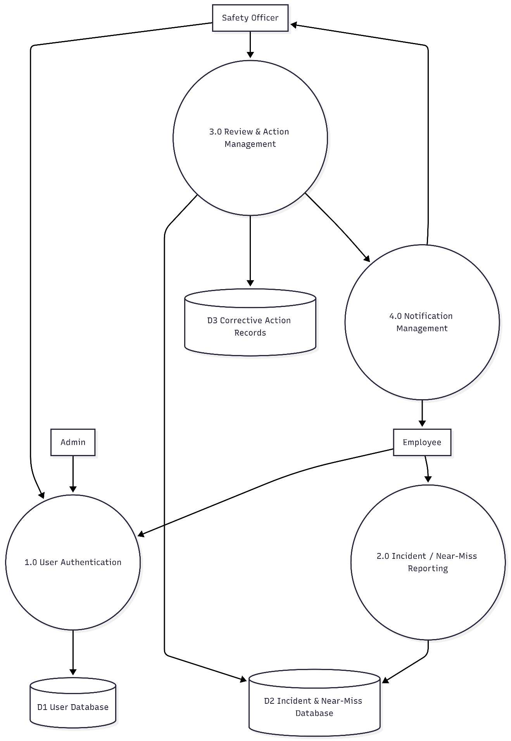 Figure 5: DFD Level 1 of the Digital Safety & Near-Miss Management System

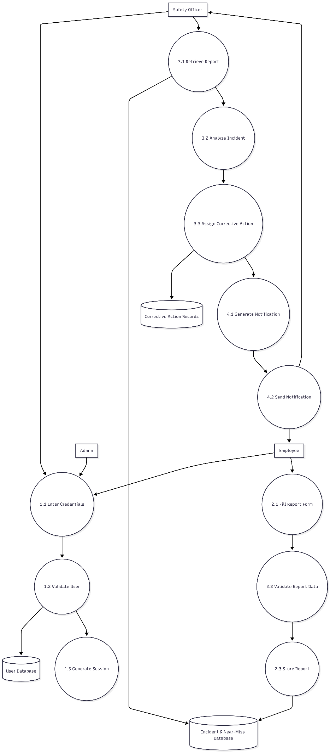
Figure 6: DFD Level 2 of the Digital Safety & Near-Miss Management System

- A user submits an incident or near-miss report using the mobile application.
- The application communicates directly with Firebase services via SDKs.
- Backend services validate and store the data in the database.
- Safety officers review the report and assign corrective actions.
- Notifications are sent to relevant users regarding status updates.

4. Technology Stack
Layer | Technology | Purpose
Frontend | Flutter (Dart) | Mobile application user interface
UI Design | Material Design 3 | Consistent and modern UI
Authentication | Firebase Authentication | Secure user login and role handling
Backend Logic | Firebase Cloud Functions | Business logic and workflows
Database | Cloud Firestore | Store incidents, near-misses, and user data
File Storage | Firebase Storage | Store images and supporting documents
Notifications | Firebase Cloud Messaging (FCM) | Send alerts and updates
Hosting | Firebase | Cloud-based, serverless infrastructure

5. Requirements Traceability Matrix
Use Case ID | Related Functional Requirements
UC-01 | FR-01
UC-02 | FR-02
UC-03 | FR-03
UC-04 | FR-04
UC-05 | FR-05
UC-06 | FR-06
UC-07 | FR-07

6. Security Architecture
- Encrypted communication using HTTPS
- Secure, token-based authentication mechanisms
- Role-based access control across all system components

7. Scalability and Maintainability
- Modular and layered system design
- Easy addition of new safety features without impacting existing functionality
- Architecture supports future scaling as organizational requirements grow

8. Conclusion
This document presents a clear, consistent, and well-structured Software Requirements Specification and high-level architecture for the Digital Safety & Near-Miss Management System. The proposed design supports effective safety reporting, proactive risk management, and continuous improvement of organizational safety culture, while remaining suitable for academic evaluation and real-world deployment.

